Firebelles Raffle Ticket Sales General Information

Prize Selection

The more popular prizes have been personal items (jewelry, lotions) and less popular items are household decorations and holiday items.
Watch for sales, places like Ross's and Home Goods are great places to pick up reasonably priced prizes.
Have at least 5 prizes, plus the free luncheon certificate. The president will give you a signed certificate each month.
Set Up

You will need at least $60 in change on hand: 2 x $10, 4 x $5, 20 x $1. The treasurer can supply this at the beginning of the year. Hold back this amount each month to use for the next raffle sale.
Have tickets pre-torn by groups of 3's and lS's. Have at least two members selling tickets. If a 3rd is available, she can walk through the tables selling more tickets.

\. ,/
Arrive to set up display by 10:30. It is helpful to display items in an attractive manner using covered boxes (etc.) to vary the heights of displayed prizes, add festive decorations.
Have a list of the prizes to display at the table. Later, use this to write the winner's name next to the prize. Give the list of winners to the Firebell that writes the newspaper articles.
Display the flyer which lists the price of tickets

Drawing

Before lunch is served and the meeting starts, ask the president to announce final ticket sales. Inform the president how many prizes are available, and if there is a special prize such as a gift card or tickets to an event.

Reimbursement/Earnings

You will be given two forms. The 1st is to list expenses for which you will be reimbursed. Have this completed and in an envelope to give to the treasure at the meeting. The second form is to list the amount of money you are turning in, again have this ready to give to the treasure at the meeting. Remember to hold back $60 in change for next raffle.

Vicki Burkley May 20l 2
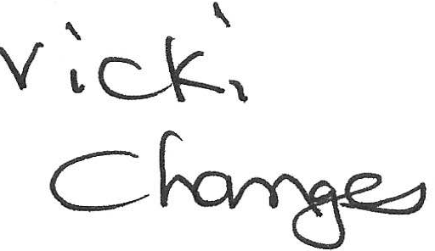
v \\.J..iill 'p._5
,ll'"l- r\C)

